Author: Anna Skowron
Institution: Jan Dlugosz University in Czestochowa
Title: All you need is code
Abstract:
The workshop is targeted at everyone who wishes to teach English in a slightly less conventional way; at everyone who wants to teach creativity, problem-solving, team work, and above all, how to think. All those skills can be taught while coding and you do not need to be an IT specialist! During my workshop, I will share some ideas for English-with-coding lessons, and the participants will have the opportunity to design their own lesson with the elements of coding, leaving the workshop with a handful of ideas on how to teach English with coding. We will be using two robots, one robot or no robots at all.

The workshop is sponsored by:
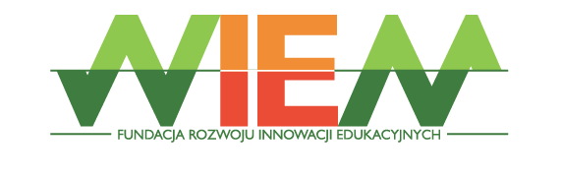
https://www.fundacjawiem.com/

